**Python Chatbot Documentation**

Welcome to the documentation for the Python Chatbot project. This chatbot is designed to engage in conversation with users, understand natural language input, and respond appropriately. It utilizes natural language processing techniques to interpret user queries accurately and provide contextually relevant responses.

**Features**

* Natural Language Understanding
* Response Generation
* Dynamic Responses
* Error Handling
* User Interaction
* Extensibility

**Code Explanation with Images**

* First starting with import necessary module
* import datetime – this is for realtime date and time
* import nltk – Natural language toolkit
* From nltk.chat.util import Chat, reflections – this class used for create chatbot and handle patterns and responses

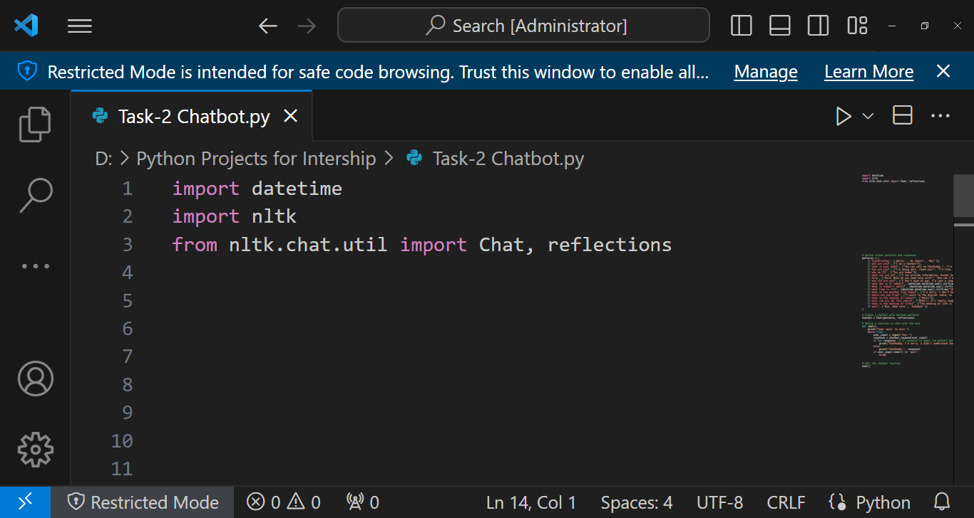

* Define intent patterns and responses

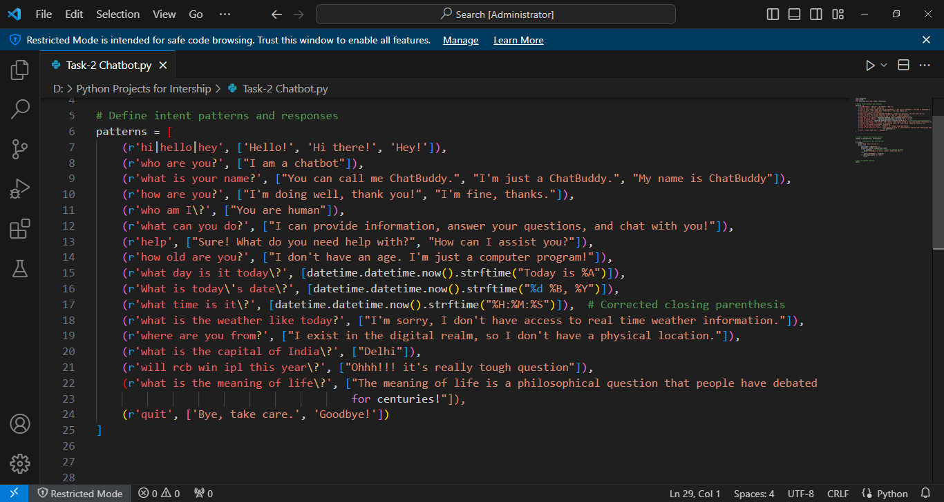

* Create chatbot with Chat class using this patterns and reflections

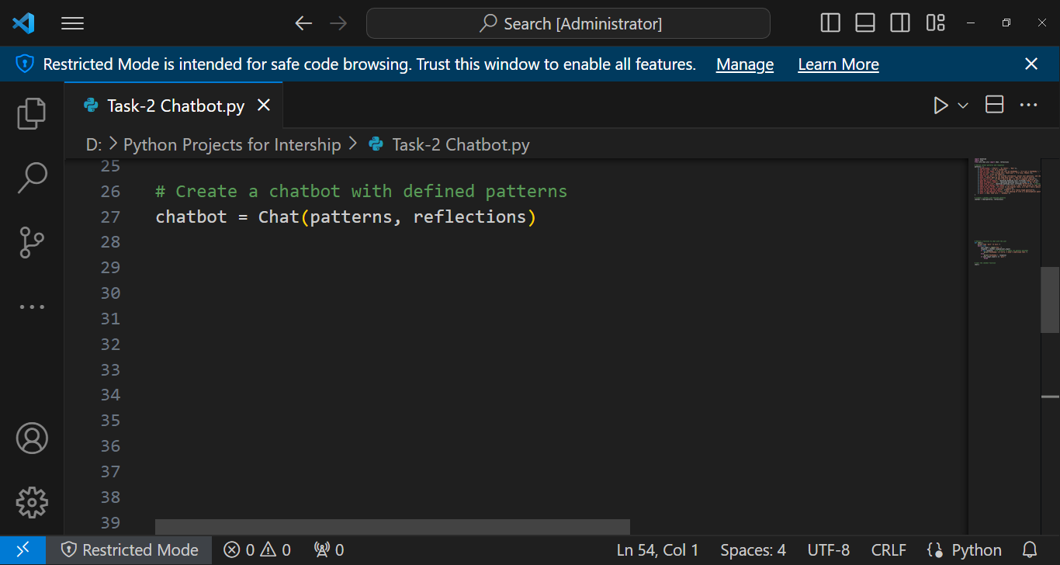

* Define function chat() for using this chatbot

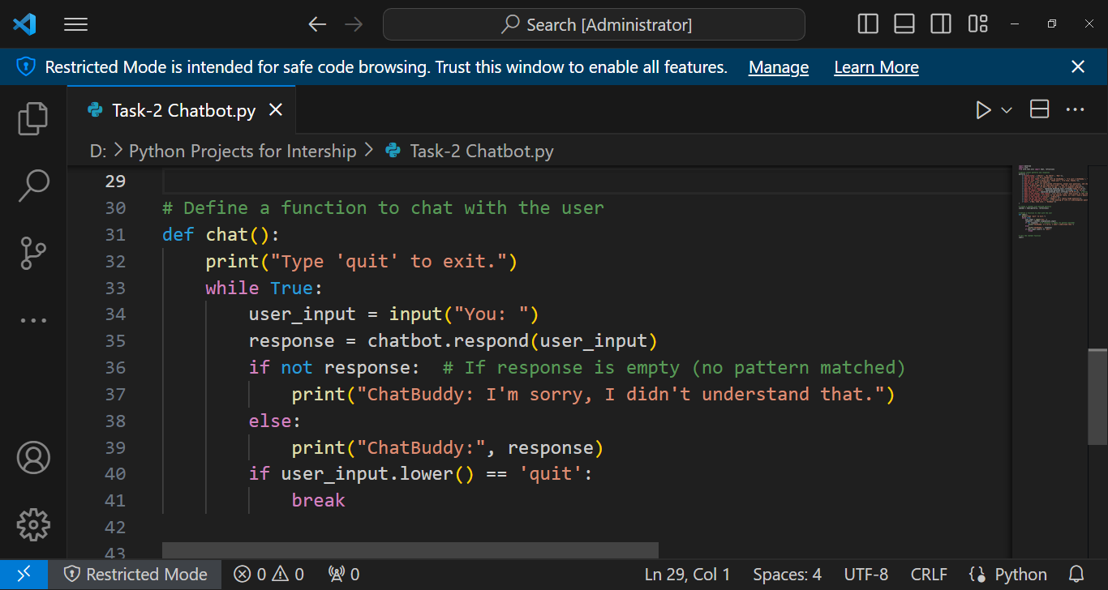

* Call the function for starting chatbot

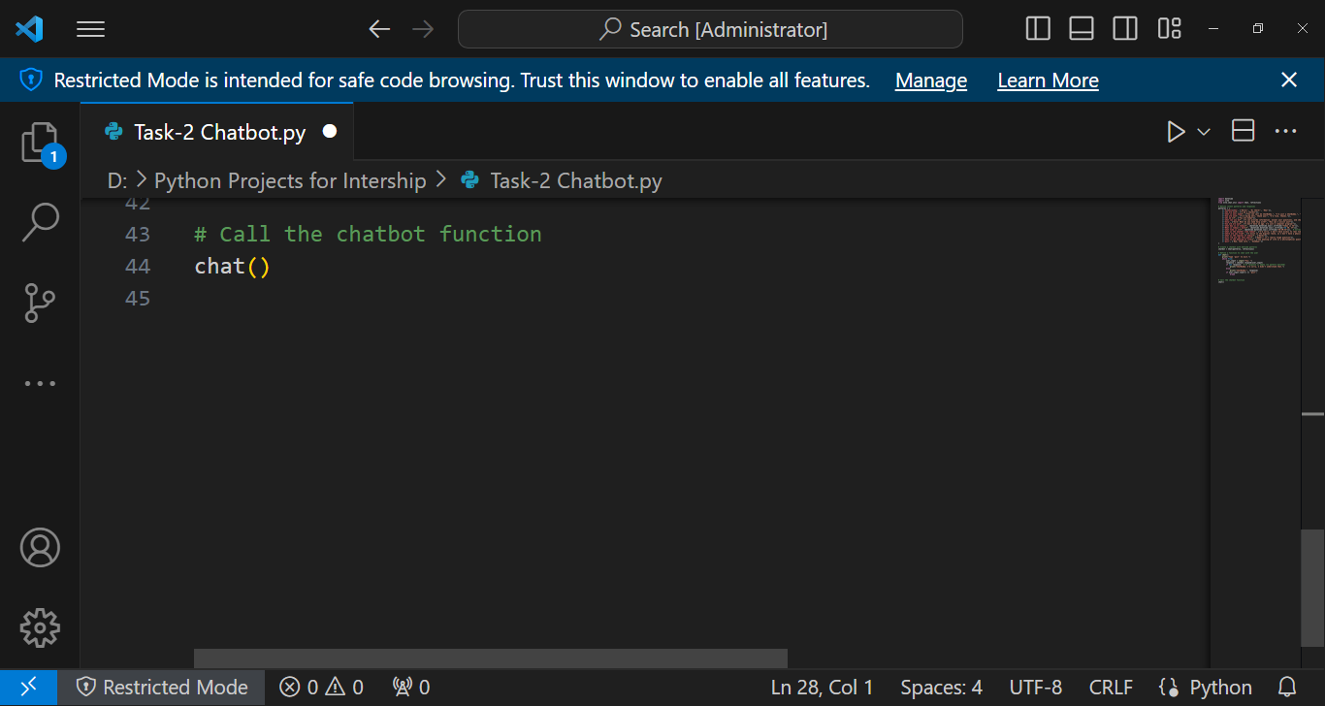

**Usage**

* Run this python script
* Ask your questions
* Get your result
* To quit the chatbot, type the "quit"

**Example**

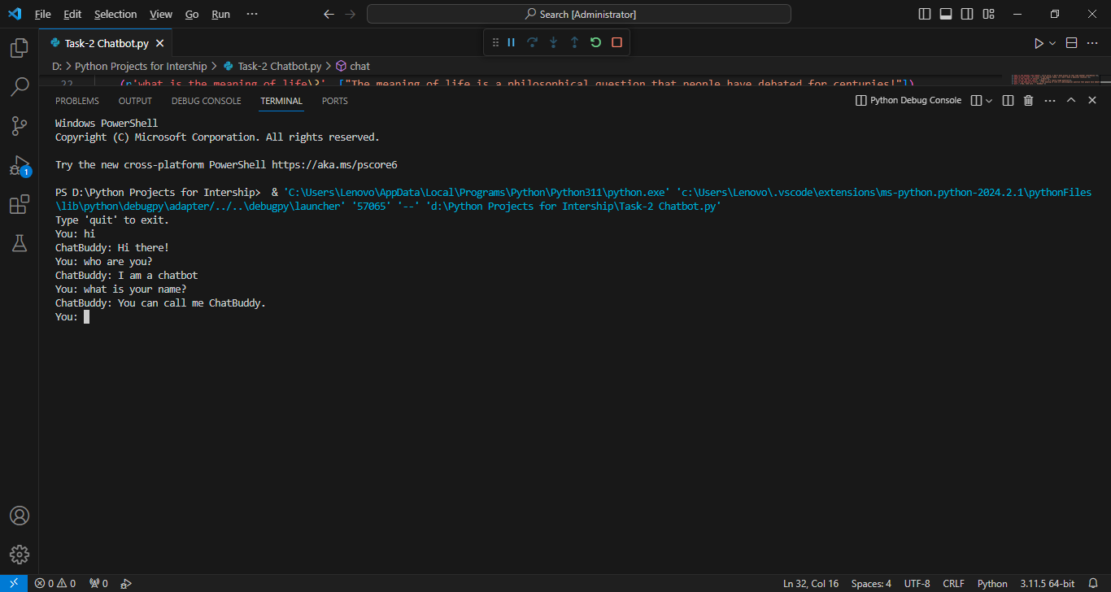

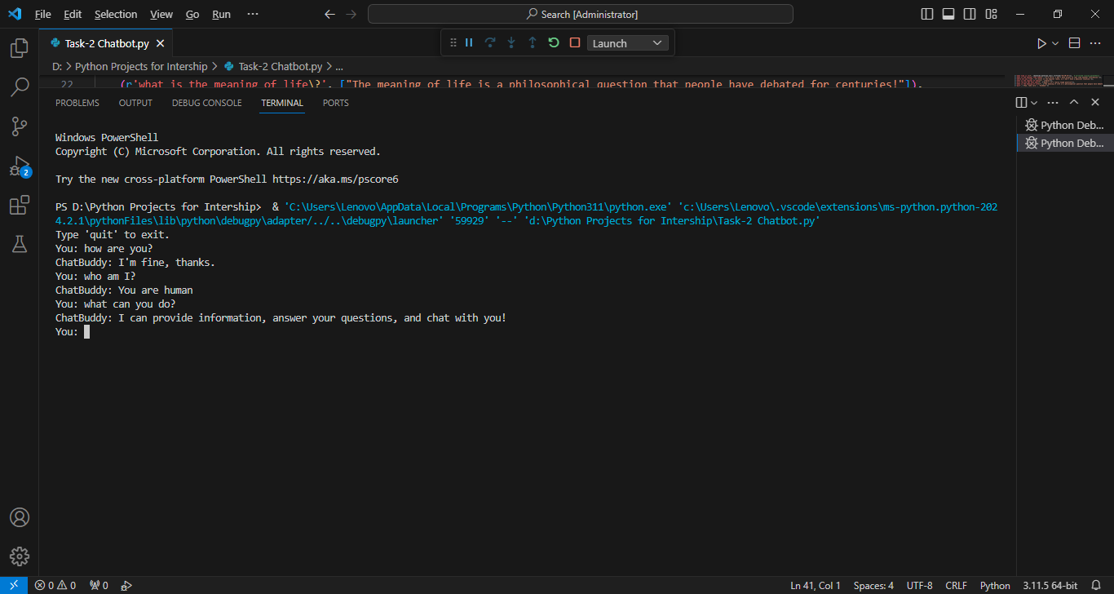

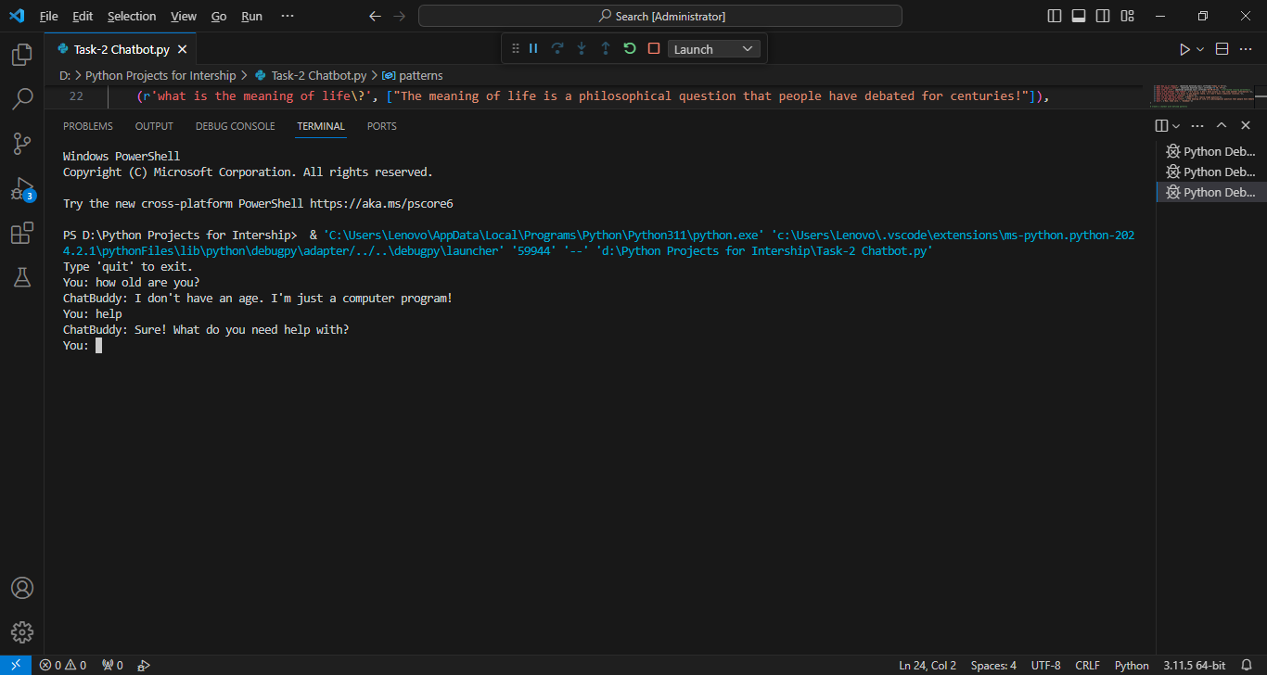

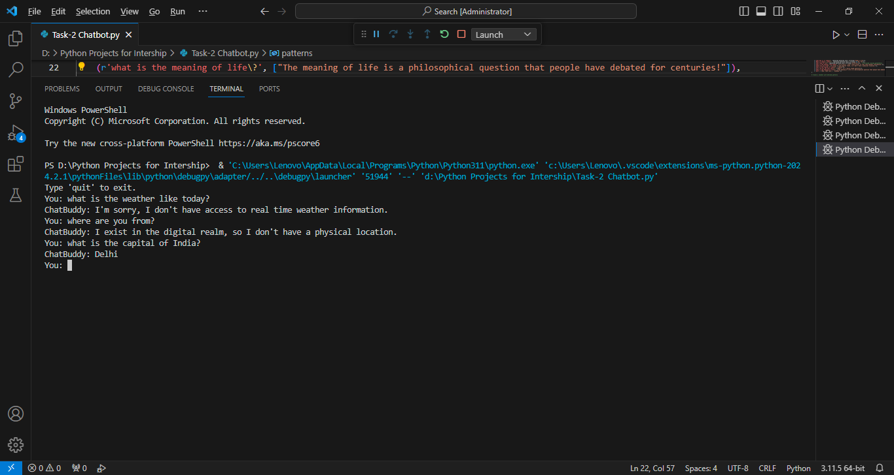

* Ask current date and time also
* Some tough questions and quit

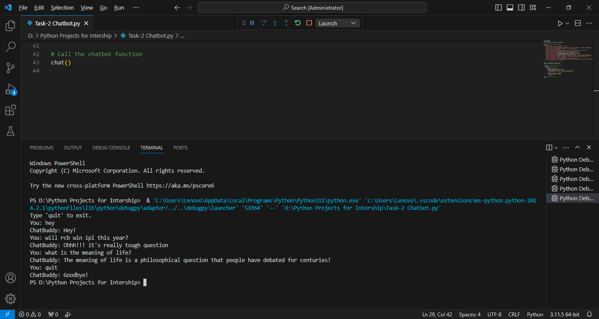

**Conclusion**

This Python program implements a chatbot capable of engaging in conversation with users. It recognizes various greetings, provides information about itself, and responds to queries about the current date and time. The chatbot handles general questions and gracefully exits upon user request. It serves as a simple demonstration of natural language processing techniques for building conversational agents.